Introduction to Research: Science Fiction and Philosophy

First two steps of your final project:
- Identify a particular new technology or new scientific discovery and use library research to become the class “expert.”
- Write an annotated bibliography for at least three sources that you use to inform your understanding of the new technology or discovery. [100 points - DUE November 15]
Suggested Research Steps
0) Create your RefWorks account to make your annotated bibliography
- RefWorks—supports direct exports from EBSCO, JSTOR, etc. Export as you research.
You may also add information to cite websites.
- RefWorks saves information on the article and direct link to article (if available)

1) Explore your concepts—Identify words to find NEAR each other

2) Use Journal List A-Z to determine access to these magazines

American Scientist Popular Science Popular Mechanics New Scientist

3) Register for the NY Times See http://library.wabash.edu/newspapers

4) Search EBSCO and JSTOR-- Proximity searching: find words near each other

EBSCO includes 10,000+ current full text journals from two dozen databases, including
Medline with Full Text 500 medical journals

Standard search: engineered meat finds 5,278 articles
Near search: engineered n5 meat finds 65 articles

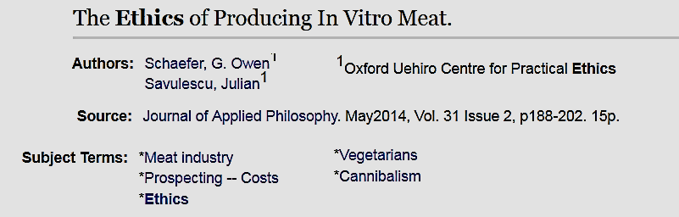
Tip: Identify great subjects!

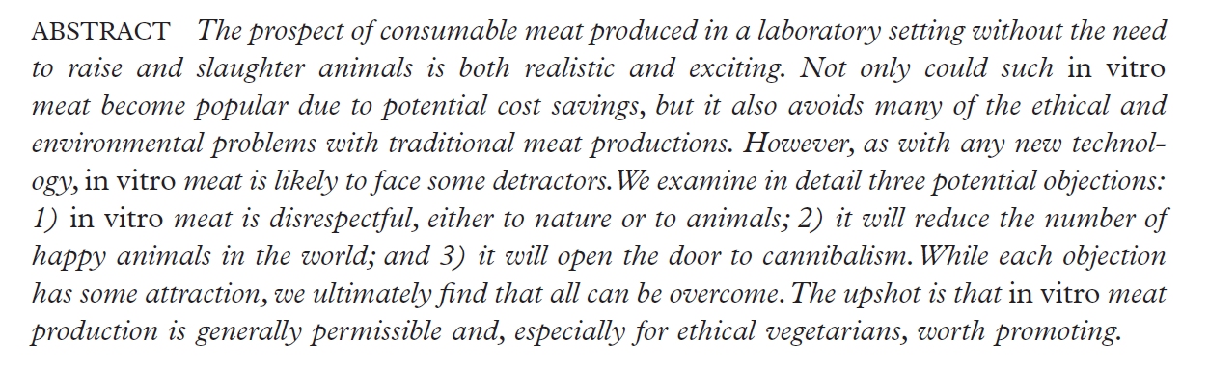

http://ntweb.wabash.edu:2048/login?url=http://search.ebscohost.com/login.aspx?direct=true&db=aph&AN=95876779&site=ehost-live

JSTOR—1000+ journals from first volume up to last 3-5 years

Standard search: pain gene therapy finds 5,248 articles
Near search: "pain gene therapy"~25 finds 47 articles

5) Use RefWorks to make your annotated bibliography
- An annotated bibliography is your summary of the source-including your restatement of the main argument of the author and the author's evidence in support of this argument
- Consider this step to be both for sorting (will this source help me extend the argument in my paper?) and beginning to write your paper (this could be the start of a paragraph in my paper).
- Choose (with notes) for your annotated bibliography
- Write-N-Cite—plug in tool for Word; cite articles saved in RefWorks as you write, including parenthetical references or footnotes.

Prepared by Jeff Beck, October 27, 2016

FRT 16-H Science Fiction and Philosophy Fall 2016
Basic Guidelines for Final Project

The final project for this course will be completed in several steps:
- Identify a particular new technology or new scientific discovery and use library research to become the class “expert.”
- Write an annotated bibliography for at least three sources that you use to inform your understanding of the new technology or discovery. [100 points - DUE November 15]
- Develop a 2-3 page report that includes summary of the main ideas in at least two of your three sources. [250 points – DUE December 6]
- Make a brief 8-10 minute oral presentation on your research in class. [250 points - Nov 15 & 17]
- Write a creative science fiction story that uses the particular technology or scientific discovery.[400 points – DUE December 13 in our final exam meeting]

Step One: Research

We will meet with the Reference Librarian, Mr. Jeff Beck, in the library on Thursday October 27. Mr. Beck will use examples from our class project ideas to give you some introduction to library research tools and techniques.

To prepare for that class, please identify an interesting new technology or scientific discovery that you would like to investigate and send me an email message describing your idea and your source before class on Tuesday October 25. Possible sources include:

New York Times Science Section
http://www.nytimes.com/pages/science/index.html

ScienceNow—current science news from the journal Science
http://news.sciencemag.org/sciencenow/

Articles on the History and Philosophy of Science from the journal Science
http://www.sciencemag.org/cgi/collection/sci_history_philo

You can also use the Library Journal List to locate electronic journals with relevant material. On the Library home page, under “Popular Resources and Services,” click on the link for Journal List A-Z. Examples of available journals and magazines include:

American Scientist

Popular Science

Popular Mechanics

New Scientist

Examples of annotated bibliographies
Kachun, Mitch. "From Forgotten Founder to Indispensable Icon: Crispus Attucks, Black Citizenship, and Collective Memory, 1770-1865." Journal of the Early Republic 29, no. 2 (Summer 2009): 249-286.

Example One: This source tells the whole story about Crispus Attucks, his importance as a forgotten founder, and what we should think about his story today.

Example Two: The article presents information on Crispus Attucks, who was reportedly the first martyr of the American Revolution. Attucks died at the Boston Massacre on March 5, 1770, after which he was recognized by African Americans as the first martyr of the American Revolution. It is stated that Attucks denoted African American patriotism, military service, citizenship, and sacrifice. Since the 1850s, African Americans have commemorated Attucks in several ways, including Attucks Day celebrations, a monument on the Boston Common in Boston, Massachusetts, and organizations named after him. In 1998 the U.S. mint issued a coin commemorating the 275th anniversary of Attucks's birth. (Copyright applies to all Abstracts.)

Example Three:
In his article, Mitch Kachun, Associate Professor of History at Western Michigan University, uses historical documents and images to explore the story of the role of Crispus Attucks in the Boston Massacre on March 5, 1770. It was a surprise to read that by 1783, the Boston Massacre was no longer commemorated, even in Boston. He argues that the importance of this date was overshadowed by the Presidential Inauguration celebrations on March 4. What began on George Washington’s second inauguration in 1793, became even more prominent with the ‘‘Republican Jubilee’’ that marked the inauguration of Jefferson in 1801. (Page 257) He notes that few newspapers commented on the closeness of the dates. He cites a rare example from Boston’s Independent Chronicle from 1807: ‘‘The contrast between this day (the Fifth of March) in the American annals, and that of the Fourth, must be striking to every Republican; for while the former brings to our remembrance the MASSACRE IN STATE-STREET, the latter leads us to the reflection of the inauguration of our beloved PRESIDENT.’’ (Page 258 emphasis in newspaper) Turning from remembrance of the date to the remembrance of Crispus Attucks, Kachun asserts that Attucks was a forgotten figure until the publication of two books by William C. Nell--Services of Colored Americans in the Wars of 1776 and 1812 (1851) and The Colored Patriots of the Revolution (1855). (Page 269) These books renewed interest in Attucks. Nell used the coincidence of the Supreme Court’s Dred Scott Decision (March 6, 1857) to hold ‘‘Crispus Attucks Day’’ on March 5, 1858. Kachun quotes another contemporary historian, Elizabeth Rauh Bethel , who said “Crispus Attucks had sacrificed his life for the liberty of a nation that had denied Dred Scott his personal liberty.’’(Pages 277-278) I will use this in my paper to show ….

Permalink: http://ntweb.wabash.edu:2048/login?url=http://search.ebscohost.com/login.aspx?direct=true&db=aph&AN=37294557&site=ehost-live

Joey Ballard: The article I found discusses how naked mole rats have a difference in their cell signaling pathway that affects their pain reception and tolerance. For a science fiction story, I thought of a world where scientists have exploited this difference and, through some sort of cross-species genetics technique, brought this trait to the human race. Countries could selectively use to essentially make people immune to pain, creating soldiers that will continue to fight after breaking bones, or sustaining substantial injuries. This would create zombie-like people who will really keep fighting to the death. Alternatively, entertainers might use this technology to make athletes immune to pain, creating a more exciting sporting environment. Both of these ideas are particularly dark, and I'm not sure that I will stick with either of them or not.
http://www.sciencemag.org/news/2016/10/how-naked-mole-rats-conquered-pain-and-what-it-could-mean-us

Looks like an interesting new discovery. You will want to look for other similar research on pain receptors and tolerance and/or research transgenic animals including potential human gene therapy. Your story need not be entirely dark if you consider the possible benefits for those who suffer chronic pain that might be eased or eliminated (e.g. disabling migraines, chronic back pain, chronic pain that seems to have no physiological cause, even end of life pain that is hard to control without affecting a person’s ability to think and interact with others).

Hunter Bates:
http://thescienceexplorer.com/technology/10-science-breakthroughs-will-change-world​

My idea (The Hive Mind) begins at the 7:45 mark of this video. It should make for a fascinating final project.

Jude Bill: Some ideas I had for research of my final project are 3D printing, VR (virtual reality) technology, or possibly some neural technology.

Chase Cochran:
I would like to research and give a presentation about the fairly recent discovery of gravity waves and how they can allow us to map out space that we cannot yet see.
If not that, then I would like to research vaccines and their supposed link to autism.

Chandler Jacks:
I am going to do my research over the theory and possibility of replicating Cold Fusion. In 1989, a group of scientists accidentally fused 2 atoms at room temperature, and though unreplicatable currently, this could solve nearly every energy source problem on Earth. Nuclear fusion usually needs several thousands of degree to occur, but fusing at room temperature would be an interesting proposal to conserve resources on this planet. Information retrieved from the American Society of Mechanical Engineers, at asme.org.

Drew Lukens: I would prefer to do my research on the Hyperloop project. The prime number interests me and is my backup idea.
- Hyperloop-
This could be the transportation of the future. Elon Musk calls it “the fifth mode of transportation”. Interesting idea that was suggested in 2013 and is still in the planning phase. This new technology will have us flying through tubes as soon as the 2020s. There are many major cities that already have plans to build their own systems.

https://www.tesla.com/sites/default/files/blog_images/hyperloop-alpha.pdf

- New prime number-
Prime numbers are very important to us as we encrypt our computers and sensitive files. The ability to find new prime numbers is a test of computing strength and a search for security. This past January a new prime number was discovered. (2^74,207,281) -1 and has over 22 million digits. It took way too much time to find and a lot of computing power. How long will it be till we discover the next prime number?

http://www.mersenne.org/primes/?press=M74207281

Israel Ortiz: The first idea that I have I could possibly use is the "Planet Nine" that was recently discovered. It would not only present a new place for man to "discover" and possibly find additional life forms. Another idea that I could possibly use is the volcano that apparently stopped a earthquake from continuing its course from the magma chamber within. I could use this as a possible short story on a distopia that occurred if the volcano was not there. Or maybe I could use the same story but state that the earthquake is the reason that the volcano had erupted and caused catastrophic/lethal damage to surrounding areas, causing the survivors to fight for their lives on a daily basis.

"Planet Nine" - New York Times
http://www.nytimes.com/2016/10/21/science/planet-nine.html?rref=collection%2Fcolumn%2Ftrilobites&_r=0

"Volcano that stopped a Earthquake" - Science Magazine
http://www.sciencemag.org/news/2016/10/volcano-stopped-earthquake-its-tracks-scientists-say

Jared Strehl:
My idea for my research topic is talking about the new discovery that bacteria (e.g. E.Coli) can be "hijacked" and programmed to create bio-films and also to latch onto certain nano materials such as gold nano particles. This bio-film containing the gold nano-particles can work as a semiconductor and since the bacteria cells communicate with one another, they can adapt to changing environments. This new discovery/technology leads to many possibilities such as better solar cells, diagnostic sensors and self healing materials.

My source is http://blogs.discovermagazine.com/d-brief/2014/03/24/reprogrammed-bacteria-build-self-healing-living-materials/#.WA6olvkrLIU​

