Quick Intro to Psychology Literature Review
A 12-15 page literature review (with 20+ references) is due at the end of the semester. Please contact Jeff Beck for help.

Start with One Good Journal Article--Identify concepts from abstract
Olofson, E. L., Casey, D., Oluyedun, O. A., Van Herwegen, J., Becerra, A., & Rundblad, G. (2014). Youth with autism spectrum disorder comprehend lexicalized and novel primary conceptual metaphors. Journal of Autism and Developmental Disorders, 44(10), 2568-2583. doi:10.1007/s10803-014-2129-3

Individuals with autism spectrum disorder (ASD) have difficulty comprehending metaphors. However, no study to date has examined whether or not they understand conceptual metaphors (i.e. mappings between conceptual structures), which could be the building blocks of metaphoric thinking and understanding. We investigated whether 13 participants with ASD (age 7;03–22;03) and 13 age-matched typically developing (TD) controls could comprehend lexicalized conceptual metaphors (e.g., Susan is a warm person) and novel ones (e.g., Susan is a toasty person). Individuals with ASD performed at greater than chance levels on both metaphor types, although their performance was lower than TD participants. We discuss the theoretical relevance of these findings and educational implications. (PsycINFO Database Record (c) 2015 APA, all rights reserved) (journal abstract)

Identify subjects, populations, age groups, and tests from article citation (EBSCO PsychINFO)

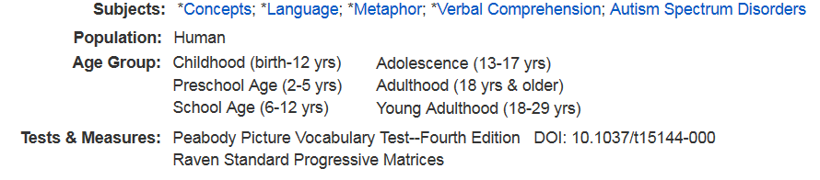

Research Diary—Conceptualize how databases differ on your concepts
PsychINFO Key index for psychology journals

Science Direct 800+ full text psychology books/journals. Advanced Search: limit to review articles.
Web of Science Index to thousands of journals since 1900, including Social Science Citation Index

Standard Searches PsychINFO ScienceDirect Web of Science
Autism spectrum disorder 33,200 17,800 31,900
“Autism spectrum disorder” 6,700 17,800 13,700

Metaphor 15,000 2,200 32,700

Autism spectrum disorder and metaphor 84 400 32
“Autism spectrum disorder” and metaphor 8 395 11

Research Diary--Contrast with search commands unique to PsychINFO

Near (n#)
“Autism spectrum disorder” n15 metaphor 6

Subjects (DE)
DE "Autism Spectrum Disorders" 31,000
DE "Metaphor" 5,600
DE "Metaphor" and DE "Autism Spectrum Disorders" 34

Thesaurus:
Explode Metaphor 27,600
DE "Figurative Language" OR DE "Irony" OR DE "Metaphor" OR DE "Analogy" OR DE "Semantics" OR DE "Antonyms" OR DE "Homonyms" OR DE "Synonyms" OR DE "Symbolism"

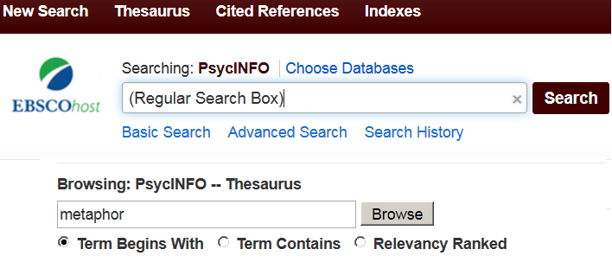
Thesaurus Search Box Regular Search Box

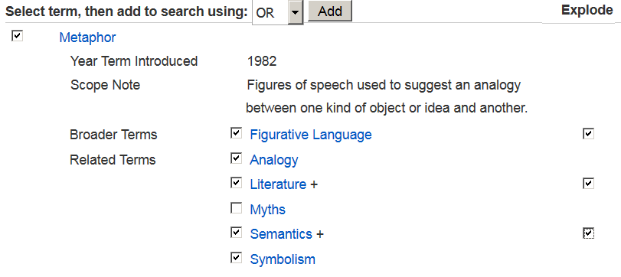

Research Diary: PsychINFO Bottom Line
Autism spectrum disorder and metaphor 84
Explode Metaphor and DE "Autism Spectrum Disorders" 230

Identify high cited/related sources with common bibliography using Web of Science

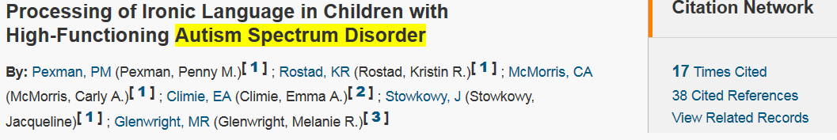

Citing Articles—More recent

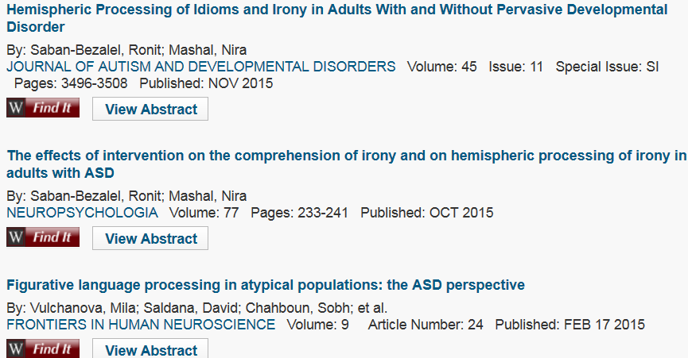

View related records (shares references)

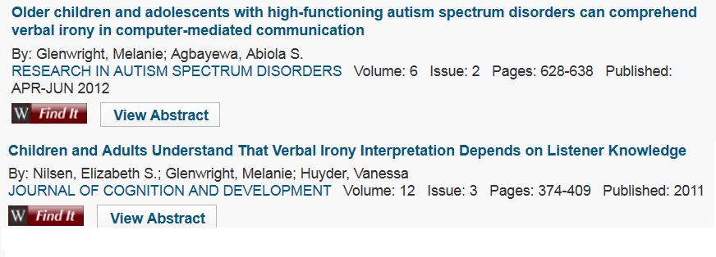

Use the citing articles or related records to identify addition citing or related articles and so on

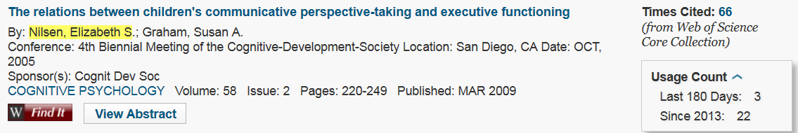

Identify the most highly cited articles/authors on your broad concepts

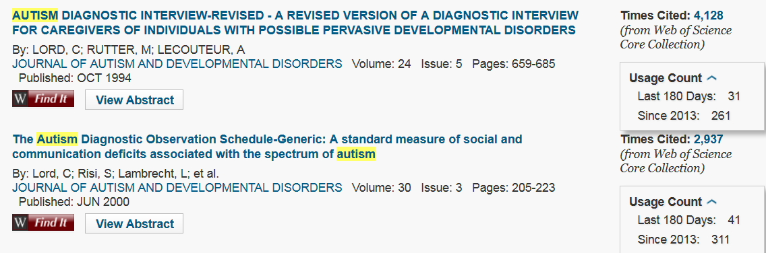

Use RefWorks to manage your references / create APA style bibliography

- Direct export from EBSCO databases, JSTOR, Science Direct, and Google Scholar.
- For Web of Science must Add new reference and cut-and-paste each element

- Double-check your references for errors!
- Write-and-Cite helps you cite sources as you write
- See http://library.truman.edu/archives/apa/style_reference.pdf
https://owl.english.purdue.edu/owl/resource/560/08/

Prepared by Jeff Beck, September 1, 2016

